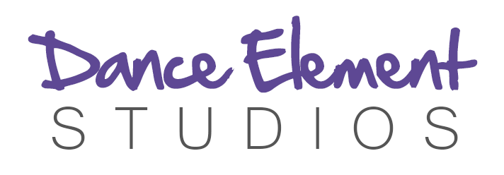

Please Complete Page 1 & 2 of this form (one per student) and email it to danceelementstudios@gmail.com
Please do not print this off and send it with your child.
ENROLMENT FORM 2019
STUDENT DETAILS
Surname:
Name:
D.O.B:
Grade at School:
Address:

PARENT/GUARDIAN DETAILS
Surname:
Name:
Mobile:
Email Address:
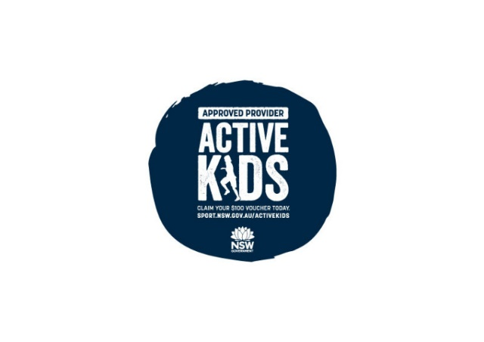
MEDICAL HISTORY (If your child has specific medical requirements, please note below).

ACTIVE KIDS VOUCHER NUMBER:
CREATIVE KIDS VOUCHER NUMBER:

PERMISSION (please highlight)
I give permission for DES to administer first aid if required Yes/No
My child’s photograph may be used for DES promotion (newsletter, website, Facebook, Instagram) Yes/No
I have read and understood the Terms and Conditions of Enrolment with DES (Page 3) Yes/No

NAME:
Date:

CLASS SELECTION
Please highlight
DES 2019 Timetable

HORNSBY STUDIO 1: Hornsby Uniting Church Hall (24 William Street Hornsby)
Monday | Tuesday | Wednesday | Thursday
Primary Ballet  4.30-5.15pm | Junior Musical Theatre  4.30-5.15pm  (5-9 years) | Junior Hip Hop  4-5pm | Intermediate Contemporary  4.30-5.30pm
Primary Jazz  5.15-6.15pm | Grade 3 RAD Ballet  5.30-6.30pm  Exam Only** | Intermediate Hip Hop  5-6pm
Open Age Tap  6.30-7.30pm |  | Senior Hip Hop  6-7pm

HORNSBY STUDIO 2: Icon Gymsports (19-21 Leighton Place Hornsby)

Monday | Thursday
RAD Grade 6  Ballet  4.30-5.30pm | Intermediate RAD Ballet  4.15-5.15pm
Intermediate Performance Jazz  5.30-6.30pm* | Pointe Class  5.15-6pm
Senior Performance Troupe*  6.30-8.30pm | Senior Contemporary  6-7.30 pm
Advanced RAD Ballet **
7.30-8.30pm

WAHROONGA ADVENTIST SCHOOL – FOX VALLEY ROAD WAHROONGA

Monday | Tuesday | Wednesday
 | Junior Hip Hop  (Prep-2)  7.30am-8.30am | Intermediate Hip Hop  (Years 2-4)  7.30am-8.30am
Infants Ballet  (Prep- 2)  3-3.45pm | Primary Ballet  (Years 1-4)  3-4pm
Senior Hip Hop  (Years 5-10)  3.20-4.20pm | Senior Contemporary  (Years 5-10)  3.30-4.30pm

ASQUITH CHURCH OF CHRIST – 3 AMOR STREET ASQUITH

Monday | Friday | Saturday
Advanced RAD Ballet  4.15-5.15pm  Exam Only**  Moved to  ST JOHN’S ANGLICAN CHURCH ASQUITH | Tiny Tots Move and Groove (Preschool 2-5 years)  10am-10.45am | Kindy Ballet/Jazz (4-7 years)  9-10 am
Intermediate RAD Ballet
5.20-6.20pm
Exam Only**
Moved to
ST JOHN’S ANGLICAN CHURCH ASQUITH
* Enrolment in this class also requires enrolment in a ballet class. These classes will perform on various occasions throughout the year, including eisteddfods.
**Price will be determined by the number of students attending the class.
Dance Element Studios Terms and Conditions of Enrolment
Payment
Fees are to be paid in full by the allocated date via direct deposit. DES will not accept cash payments. Term fees are non-refundable. DES does not refund missed classes. Students may participate in a ‘make up’ lesson upon arrangement with the DES office within the same term as the missed class. Please contact DES if you have any enquires regarding your account. If enrolling mid-way through the term the invoice will be calculated at a pro-rata rate. DES may cancel a class due to low numbers or alternatively if discussed with students/parents if they wish to continue, a higher fee or rate may be charged. Upon receiving Active Kids and Creative Kids vouchers, DES will deduct the correct amount from your term invoice.
Trial Lessons
DES offers trial lessons. If the student continues with classes and enrols with DES, they are required to pay for the week of the trial lesson and all lessons following. If the student does not continue classes with DES the trial lesson is free.
Enrolment
For legal reasons and safety requirements, an enrolment form must be completed at the commencement of each new dance year by all students. It is the families’ responsibility to inform the office immediately of any changes to personal contact or health details. All correspondence to parents/students is via email. Placement of students into appropriate level classes is carefully considered due to its effect on the student’s development, confidence and safety. Final placement is at the discretion of the Director.
First Aid
First aid will be administered when required. If you do not want your child to receive first aid in the case of an emergency, please ensure you indicate NO on the enrolment form.
Safety Procedures
The safety of the students, who attend classes at DES before and after class, is the responsibility of their parents/guardians. A student must wait on the premises. DES will not be forthcoming in the responsibility for any student involved in any unsafe behaviour or practices, outside of class time. Please Note: DES is a NUT FREE ZONE (excluding our Wahroonga Adventist classes). DES is released from all liability in the event of an injury or loss pertaining to the unapproved use of studio property including furniture, decoration, fittings and property/equipment.
Video and Photography
Photography and footage of students at DES may be required for activities, events and promotional purposes (website, social media, advertising material, newsletters). Neither you nor your child will be identified by full name or any personal information disclosed. Please inform the DES office if you do not wish your child to be photographed.

Class Conduct
Due to safety and class disruption, friends and family members are asked to remain outside the dance classes (except for Tiny Tots and Kindy classes). DES will offer viewing weeks to observe the students’ progress throughout the year. Please ensure your child does not bring to class any valuables or electronics. Mobile phones are permitted, however must be on silent and are not to be used during lessons. Students are expected to use appropriate language in class to respect and consider other students and teachers. No form of bullying, harassment or discrimination will be tolerated by DES. If an issue occurs class teacher must be notified ASAP. Bottled water only in studios. Food should be eaten outside or in waiting areas.
Uniform
Uniform information is available on our website. Students are required to wear appropriate footwear for style of class. These can be purchased from Bloch.

